The Literacy Mini-Assessment Sorter
User Guide

What is it?
The SAP Literacy Mini-Assessment Item Sorter provides information about each question contained within the SAP mini-assessments for Literacy, allowing users to locate individual questions that are based on specific standards. When using this tool, users will organize the spreadsheet using the sort and filter function of Excel.

How can I use it?
One use could be to find all items in a particular grade for a specific standard. The example below outlines the process for filtering the sheet to identify all grade 5 items that test Reading for Information Standard 2.

Step 1: Select the arrow in the Grade column (column A):
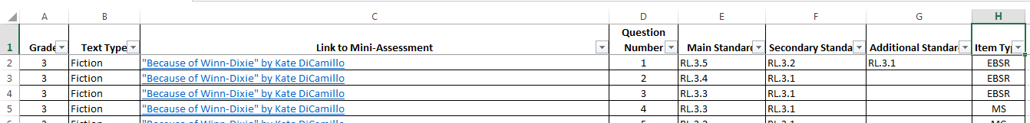

This will open a menu of all of the possible options for grade levels.

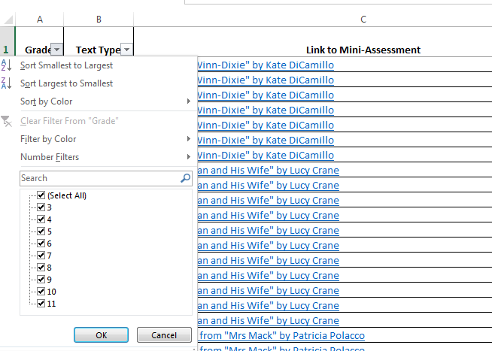

Uncheck the box next to “(Select All).” This will uncheck all of the boxes and allow you to select the single grade (or grades) to filter by:

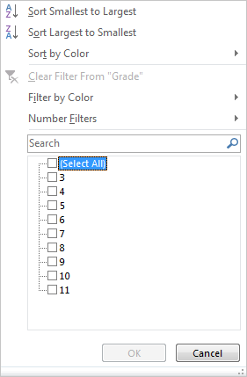

Select the grade you would like to filter by. In this example, g. 5:

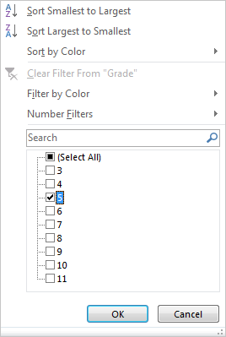

Click “OK” to apply the filters.

This will filter the sheet so that only questions associated with grade 5 texts appear:

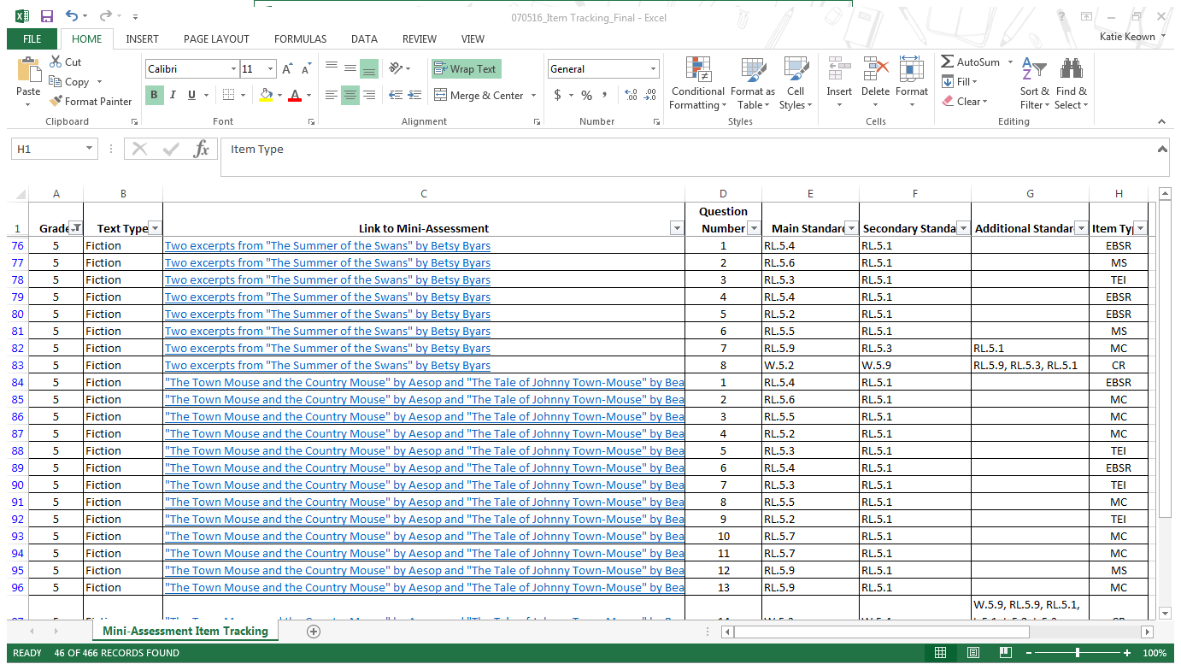

Step 2: Filter for the type of text you would like; in this example, because you are looking for the Reading for Informational standards, you will search for all nonfiction texts. Select the arrow next to “Text Type” (Column B). When the menu opens, uncheck the box next to “(Select All)” and check the box next to Nonfiction.

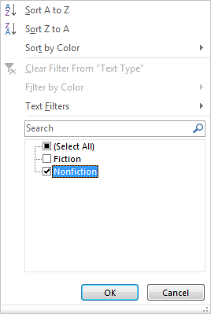

As before, click “OK” to apply the filter.
Now, the only questions that appear are those that are associated with grade 5 nonfiction/ informational texts:

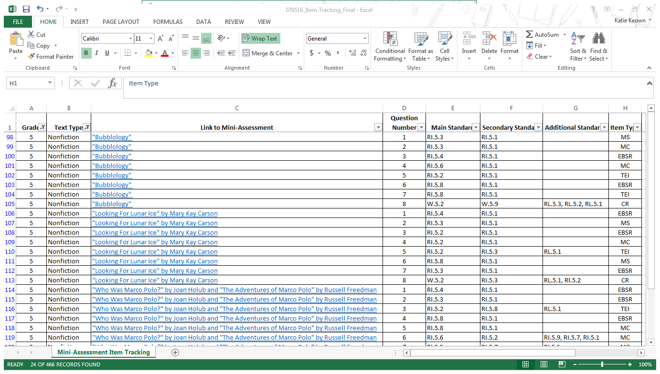

Step 3: Filter the Main Standard column (Column E) for the standard you would like to see, in this example let’s use RI.5.3. Select the arrow next to “Main Standard” in column E. When the menu opens, uncheck the box next to “(Select All),” and then choose the box next to the standard you are searching for:

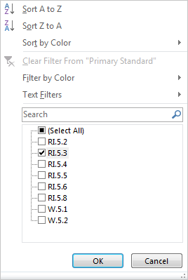

As before, click “OK” to apply the filters.
Now, you will see all of the items that are primarily aligned to Reading for Information Standard 3 at grade 5.
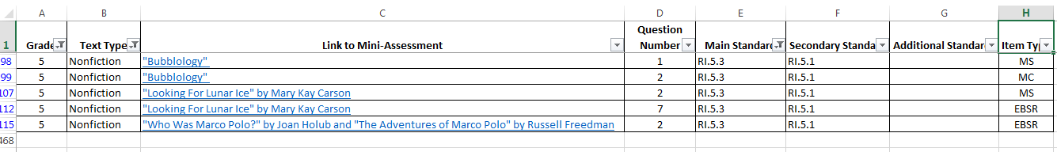

As you can see, there are 5 items that are aligned to RI.3.5 (Reading for information Standard 3 at grade 5).
- “Bubbology” items 1 and 2
- “Looking for Lunar Ice” items 2 and 7
- “Who Was Marco Polo?” and “The Adventures of Marco Polo” item 2

To view each question, click on the title of the mini-assessment in Column F. This will take you to the individual mini-assessment page. From these live links, you can download the files containing the questions you’ve identified as aligned to RI.5.3.

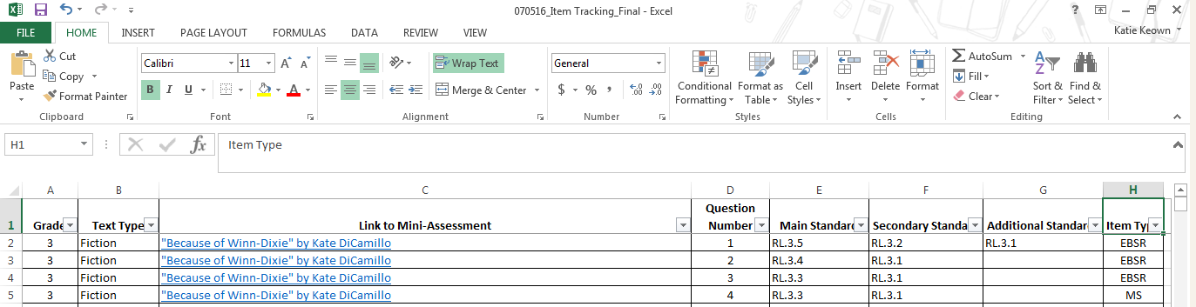
If you would like to repeat the process to search for a different standard, you must first clear all of the filters you have previously applied. To do this, click on The Sort and Filter button in the upper right hand corner of the Home Ribbon:

This will open a new menu:

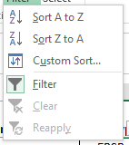

To remove any existing filters, simply click the funnel next to “Clear.”
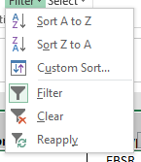

The sheet again shows all mini-assessments and associated items:

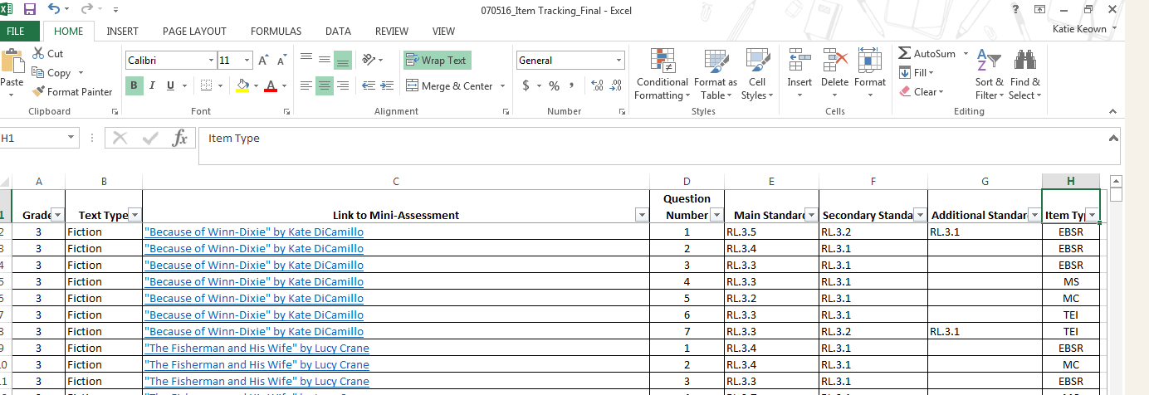

One helpful hint:
If you see a funnel next to any column title, a filter has been applied to that column.
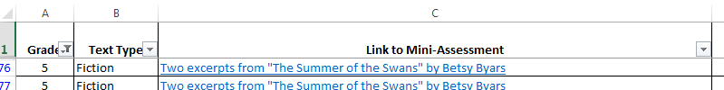

You can clear the filters as described above, or by clicking on the arrow in that column to re-open the filter menu and selecting “Clear Filters from ‘Column Name’”:
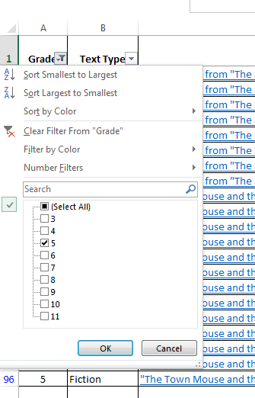

Click “Okay” and you will remove the filter from this column:
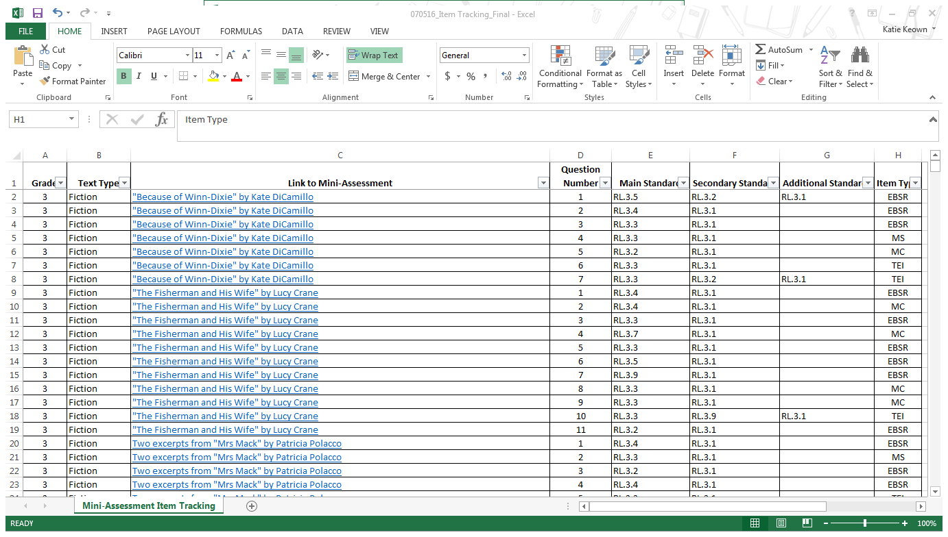

There are other ways to use the information contained within the Literacy Mini-Assessment Sorter. Explore the various ways you can sort the information to be useful to you!

